**MAHATMA GANDHI KASHI VIDYAPITH, VARANASI**

**महात्मा गांधी काशी विद्यापीठ, वाराणसी**

**(An Uttar Pradesh State University)**

**CERTIFICATE**

This is to certify that **SHASHANK KUMAR SHARMA** Roll Number: **10020517064** student of **MASTER OF COMPUTER APPLICATION**, Fifth Semester, Department of Computer Science & Applications of **MAHATMA GANDHI KASHI VIDYAPITH UNIVERSITY VARANASI**, has pursued the Minor Project entitled “**ONLINE LEARNING**” under the supervision of **Asst. Professor Vijendra Pratap Singh** and the report has been submitted to in partial fulfillment of the requirements for the award of the degree Master of Computer Application in academic year 2019-2022.

DATE: SIGNATURE OF DEAN SIGNATURE OF SUPERVISOR



**DECLARATION**

I hereby declare that the project work entitled “**Online Learning**” submitted to the **Mahatma Gandhi Kashi Vidhyapith, Varanasi** is a record of an original work done by me under the guidance of **Prof. Vijendra Pratap Singh**, and this project work is submitted in the partial fulfillment of the requirements for the award of the degree of **Master of Computer Applications in Department of Computer Science & Applications.** The results embodied in this Mini Project have not been submitted to any other University or Institute for the award of any degree.

**Shashank Kumar Sharma**

Roll No.: 10020517064

(MCA 6th Semester)

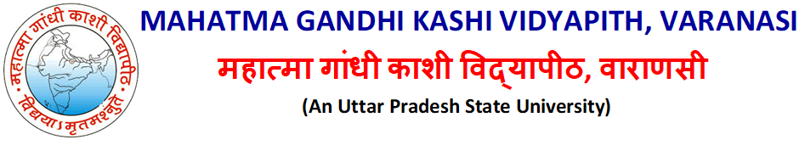

**ACKNOWLEDGEMENT**

I express my sincere regard and indebtedness to my project under guidance of **ASST. PROFESSOR VIJENDRA PRATAP SINGH** for his valuable time, guidance, encouragement, support and cooperation throughout the duration of our project. I would sincerely like to thanks Computer Science Department for giving me the opportunity to work on enhancing my technical skills while undergoing this project. This project helped in understanding the various parameters which are involved in the development of a web application and the working and integration of front end along with the back end to create a fully functional web application. I would like to thank **PROFFESOR SATYA SINGH**, Head of Department and whole of department for their constant support.

Place: Varanasi **Shashank Kumar Sharma**

Date: Roll No.: 10020517064

(MCA 6th Semester)



**PROJECT TITLE**

**ONLINE LEARNING**

**CONTENTS**

|  |  |  |
| --- | --- | --- |
|  |  |  |
|  |  |  |
|  |  |  |
|  |  |  |
|  |  |  |
|  |  |  |
|  |  |  |
|  |  |  |